O Diagram Teacher Guide

Content | What is O diagram? |  | 1
Content | Positive outcomes expectable |  | 1
Content | Design of the O diagram |  | 2
Content | Suggested applications |  | 5
Content | Laboratory | O note  A way to bring together theory and practice in action | 5
Content | Laboratory report | O report  A relational and dynamic alternative to tradition report writing | 6
Content | Share your ideas |  | 6

What is O Diagram?
O diagram is a tool that can be used in all sorts of experiments and investigations. It is a template for a different form of experimental report which engages students in thinking about the links between experimental designs and the theories behind them, and those between the question and the answer of an investigation.

Positive outcomes expectable
- Better understanding of the reasons behind experimental designs
- Become more conscious of the objectives of an experiment

Design of the O diagram
O diagram is a tool designed to bridge the gap between theory and practice in a laboratory setting. It requires students to do a bit of preparation before doing an experiment and be conscious about the reasons behind each step as they carry out the experiment. The in-page instructions explain how this is achieved.
How to use?
Before the laboratory class, write inside the circle all theories and key concepts that you can think of that are relevant to the experiment going to be carried out during the class.
Work anti-clockwise through the circle, from hypothesis to conclusion.
As you carry out the experiment, record on the outside of the circle the steps you’ve taken, and write the reason for each step inside the circle, adjacent to the steps. If a reason is already in the circle (e.g. a theory you’ve written down before the experiment), draw a line to link the step to it.

The conclusion joins the hypothesis.
Rationale: The O shape of the diagram joins the beginning and the end of an investigation. This tells that the conclusion should be answering the hypothesis, hence keeping the goal of the experiment clear.

Milestones to show the main stages of an experiment
Students are asked to input theory and procedure on the inside and the outside of the O respectively.
Rationale: Graphically expressing that procedures are evolved around theories

The O shape report template
Rationale: The O shape carries the symbolic meaning of endlessness. It not only joins the hypothesis and conclusion of an investigation, it also implies that the conclusion of one investigation can become the hypothesis of the next, thus expresses that the pursuit of knowledge should never end.

Procedures

Here is an example of how a completed O diagram of an experiment might look like:

On the next page is a sample of an O diagram completed by students:
Theory
Conclusion
Hypothesis
Procedures
Set up
Record of data
Data analysis
Measure 5 ml of potato pulp and 5 ml of hydrogen peroxide
The chemical reaction between the two generate foam, which is measurable.
Place in different water baths 10C, 20C, 30C, 40C, 50C, 60C
Enzymes work at different rate at different temperature
Potato contains an enzyme
Hydrogen peroxide has covalent bonds
The chemical reaction between this enzyme and H2O2 breaks the covalent bonds and releases oxygen
Chemical reaction has a reaction rate, which is measured by time.
Measure the height of the foam after 5 minutes
Temp. °CHeight of foam
(cm)Time (min)12
22
31
38
52
631
2
8
10
0
05
5
5
5
5
5
No data analysis required
Clear differentiation in data observed, which is sufficient for the current study
Present data on a graph
To show the trend
There is an effect of temperature on the reaction between potato pulp and hydrogen peroxide.
The enzyme in the potato pulp functions slowly in cold temperatures and does not work at high temperatures
At cold temp (12C & 22C) a very slow and very minimal reaction occurs; foam rises 1-2 cm.
At 31C-38C a rapid reaction occurs, and the foam rises to 10cm.
At 52C and 63C no reaction occurs.
There is an optimal temp in which the enzyme works
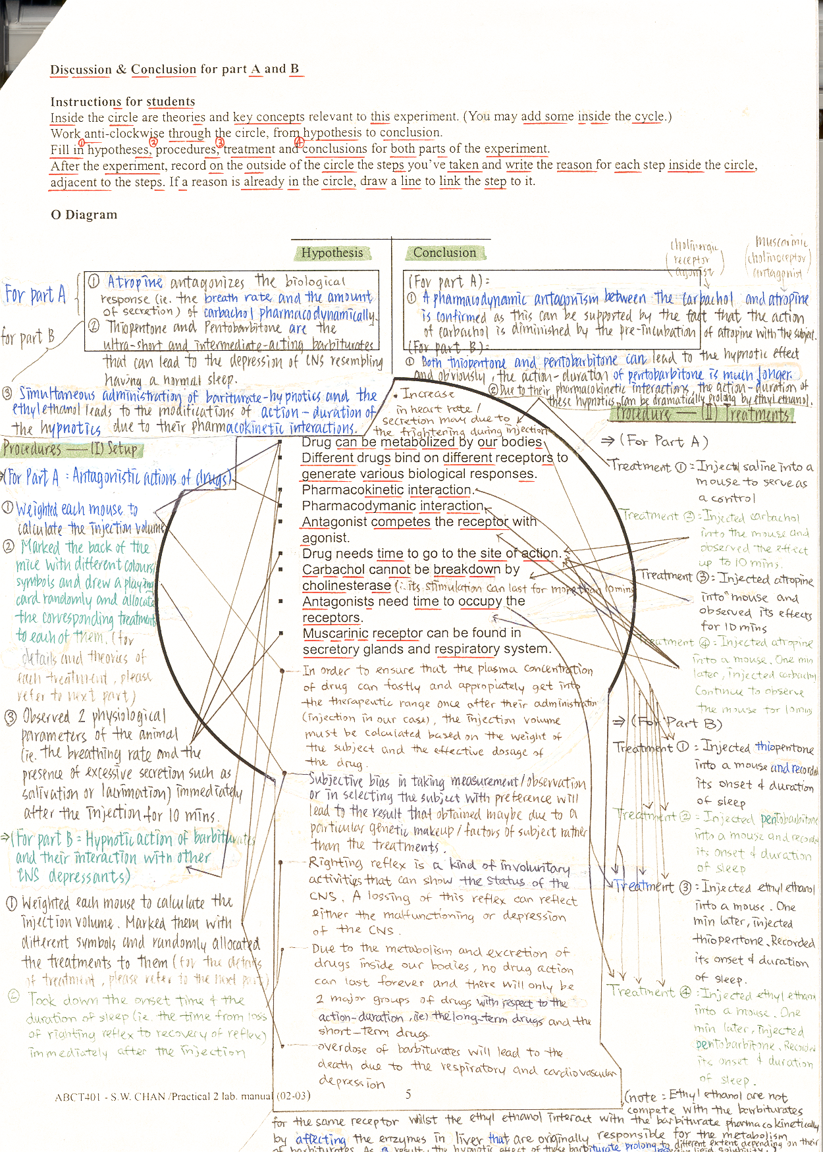

Acknowledgements: Special thanks to Mr Chan Shun Wan and Mr Ho Wing Ho from the Department of Applied Biology for providing the above example.
Laboratory O note
O diagram provide a means for preparing students for experiment beforehand and during the experiment. This exercise requires students to prepare their laboratory by writing in the circle the relevant theories and concepts, which spark off the connections between theory and practice as they use the diagram to record their actions during the practical.

Here is a sample instruction for students:

Instructions

Objectives of the exercise:
This exercise helps you understand the experiment in relation to the theories the underlie it.

Before laboratory class:
- Prepare the class by writing inside the circle all the theories and key concepts relevant to the experiment you are about to carry out at the laboratory
Tips: write in point form.

As you carry out the experiment:
- Work anti-clockwise through the circle, from hypothesis to conclusion
You may choose to include writing the hypothesis in your preparatory work before the class.
- As you carry out the experiment, record on the outside of the circle the steps you’ve taken and write the reason for each step inside the circle. If a reason is already in the circle (e.g. a theory you’ve put down before the experiment), draw a line to link the step to it.

You are required hand in this diagram along your lab report.

By doing this exercise, you will:
- Avoid carrying out the procedure without understanding it
- Have a better understanding of the theories and concepts that underlie the experiment

Note to teachers:
An empty worksheet might be intimidating for students when it is new to them. You may choose to make some input to the inside of the circle (theories and concepts) for the first few times. This makes the structure of the diagram more readily legible to your students and prevents them from getting de-motivated as they are not sure what to put where, thus allows them to gain the full benefit of this method.

Laboratory Report O report
O diagram could also be used as a template for laboratory report, either to replace the traditional report, or as an additional component. This format engages students in thinking about the links between experimental designs and the theories behind them.

Here is a sample instruction for students:

Instructions

Objectives of the exercise:
This exercise helps you understand the experiment in relation to the theories the underlie it.

The report…
- Inside the circle are theories and key concepts relevant to this experiment (you may add your own).
- Work anti-clockwise through the circle, from hypothesis to conclusion.
- Record on the outside of the circle the steps you’ve taken and write the reason for each step inside the circle. If a reason is already in the circle, draw a line to link the step to it.

Date of submission:
31-10-2002

By doing this exercise, you will:
- Avoid carrying out the procedure without understanding it
- Have a better understanding of the theories and concepts that underlie the experiment

Share your ideas
Send us your experience of using this tool to share with your fellow teacher!
http://www…

